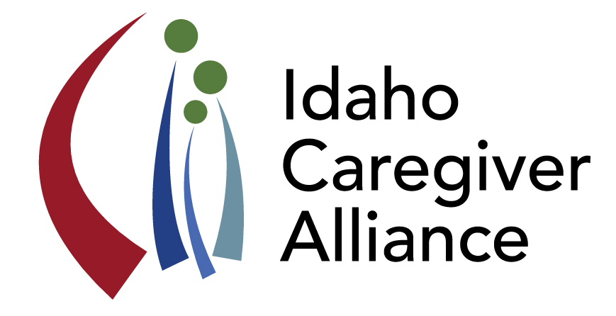Idaho Caregiver Alliance

Quarterly Meeting Minutes

2/25/2016

Location: AARP Idaho Offices

Attendees: 20 (names on file)

1) Updates

* New ICA logo reveal, Tami Cirerol
* New ICA website reveal, Kelle Sweeney
  + The ICA website is being house on the Center for the Study of Aging page at Boise State University. The website address is: <http://hs.boisestate.edu/csa/caregiver/>
  + **Please send additional resources and comments about the web-resources to Kelle Sweeney at: kelle@fiaboise.org**
* Idaho Partnerships Conference on Human Services Partnership Conference, Marilyn Sword
  + ICA will sponsor a Caregiver Tract; topics to include Powerful Tools for Caregivers; What Now?; Legal issues for caregivers; Respite; and others
  + Conference planning meeting: March 15th
* *Action Item:* Stephen Graci, Kelle Sweeney, and Pam Catt-Oliason volunteered to help plan the Caregiver Tract
* *Action Item:* visit conference website for details, <http://www.idahopchs.com/>

2) Caregivers in Idaho Report, Marilyn Sword

* Presentation of the Caregivers in Idaho report was well received by members of the House and Senate Health and Welfare Committees. The discussion was left with a commitment for an “ask” next legislative session. The “ask” will include the endorsement of an Idaho Plan for Family Caregivers.
* Discussed the Priorities Worksheet (see attached)
* ***Action Item:*** Members asked to review Priority Areas and identify those that complement work underway within their community and/or organizations
* *Action Item:* Marilyn and team working on state plan will solicit input from members

3) Powerful Tools for Caregivers, Kelle Sweeney, kelle@fiaboise.org

* Kelle shared information regarding the Powerful Tools for Caregivers (PTC) program, <https://www.powerfultoolsforcaregivers.org/>
  + The goal is to deliver the PTC curriculum in each region of Idaho. Activities include:
    - Recruitment of PTC facilitators from each region
    - Delivery of training to facilitators
    - Delivery of at least two PTC classes in each region of the state by December 2016.
  + Grant funds will be used to cover travel and other training related expenses and to support the delivery of at least two PTC classes in each region of Idaho.
    - Training tentatively scheduled for July.
* ***Action Item:*** Please contact Kelle if you are interested in participating in the PTC training.
* ***Action Item:*** Contact Kelle if your agency/organization is interested in serving as a regional PTC sponsoring agency.
* *Action Item:* see PTC website and attached information for details about PTC

4) Emergency Respite Update, Stephen Graci

* Stephen discussed the vagueness of the term “emergency,” which hinders caregivers’ access to emergency respite. Caregivers also do not use respite because they are unable to find a provider, especially in rural areas in Idaho. There is also a lack of qualified providers.
* As currently established, the caregiver is responsible for locating and securing a respite provider. This also hinders a caregiver’s use of respite. (How do you find a provider without some sort of centralized hub of information?)
* There is a liability issue for respite providers that need to be addressed when developing respite programs or a registry.

5) ICA Plan for Sustainability, Sarah Toevs

* The mission of the ICA is to be the voice of Idaho caregivers.
* Sarah discussed the proposed Sustainability Plan (attachment with meeting agenda).
* ***Call to Action:*** ICA members were asked to share the ICA Plan for Sustainability with their respective communities and organizations.
* *Action Item:* Members of the ICA leadership team – Pam Catt-Oliason, Sarah Toevs, and Marilyn Sword are available to meet with individuals/organizations to discuss sustainability and funding models.

6) Idaho Council on Developmental Disabilities Presentation, Tracy Warren

* Tracy shared the vision and purpose of the DD Council, including a description of the Asset Based Community Development and Medicaid Services Systems Changes. The DD Council engages in person-centered planning, using the Charting the Lifecourse approach to counseling.
* Current research endeavors include the HCBS Study and the Self-Direction of Service Use in Idaho project.
* *Action Item:* Members were asked to complete DD Council Strategic Planning survey, sent to ICA members on 2/29/2016.

7) Health and Welfare Website Reveal, Dieuwke Dizney-Spencer

* Dieuwke revealed two new H&W websites:
  + Live Better Idaho, <https://www.livebetteridaho.org/>
  + Idaho Wellness Guide, <http://wellness.idaho.gov/>
* The Live Better Idaho website will include service and resource information from across H&W departments as well as private organizations.
* The Idaho Wellness Guide website is based on the Stanford model of chronic disease self-management. The website can be used by providers and clients to access information on resources. Information maintenance is the responsibility of the contributing organization.
* *Action Item:* Members were encouraged to visit websites (both sites are under development and will continue to expand)

8) Behavioral Crisis Project and Policy Activities, Sarah Toevs

* Sarah provided an overview of the findings from analysis of information from Ada County Paramedics and focus groups with members of the H&W Crisis Team, hospital-based social workers, and former district attorney (attachment sent with meeting agenda)
* This information has been used to inform legislators of the challenges of providing appropriate care for individuals experiencing a behavioral crisis and their families or care givers. Specific legislative actions include:
  + Increase state-wide access to Nursing Facility Behavioral Care Units by creating a more conducive business environment for long-term care facilities to operate these units;
    - Action Step: Communicate lack of access to Behavioral Care Units to the Department of Health & Welfare (DHW) and negotiate a rule change(s) to IDAPA Code #16.03.10.268 to facilitate the creation of more of these Units in Idaho
  + Create a more conducive regulatory environment (interpretation of regulations) for Assisted Living Facilities so that Idahoans suffering from ADRD can access these facilities;
    - Action Step 1: Discuss challenges associated with interpretation of regulations with legislators.
  + Update the Idaho (Civil Commitment Code) Sections 66-317 and 66-329 to include under “Definitions” of “Mentally Ill” the word “dementia” as a mental health disorder; strike the words “or aged” from section 13a and add to the end of section 13a the phrase “and is a danger to themselves or others.”
    - Action Step: Propose legislation to change Idaho Code to allow specifically for involuntary commitment of people with a diagnosis of dementia whose behaviors place themselves or others in danger
* The focus of these policy initiatives has been to balance actions with the need to assure safe living environments and protection of the rights of an individual. These efforts have been lead/supported by:
  + “Committee of Concerned Citizens” is made up of the Idaho Alzheimer’s Planning Group, Idaho Caregiver Alliance, Justice Alliance for Vulnerable Adults and other concerned individual citizens.
  + “IHCA” is the Idaho Healthcare Association.
  + “Community Groups” are stakeholder organizations such as the Idaho Chapter of the Alzheimer’s Association, and the Idaho Culture Change Coalition (iCARE)

Save the Date: Idaho Caregiver Alliance Meeting - **Thursday, June 23, 2016 (1-4 pm)**