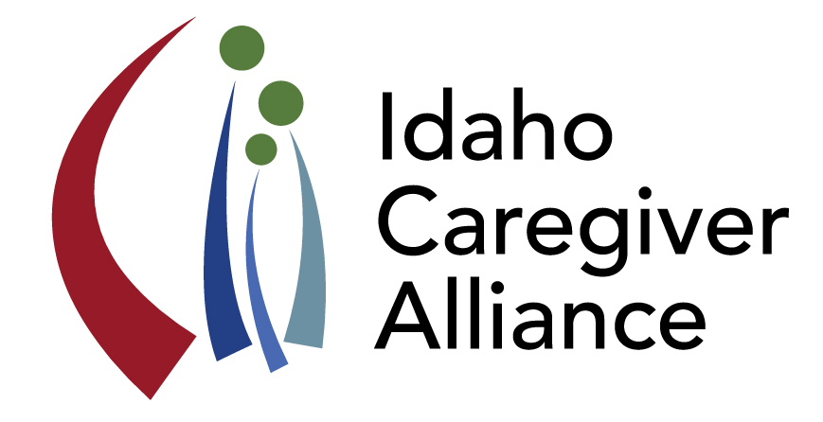Idaho Caregiver Alliance

Quarterly Meeting Minutes

06/30/2016

**Meeting Minutes**

List of 27 Attendees on file.

1) Updates:

* Welcome and introductions; Tiffeny Stees introduced as student intern for ICA.
* Blue Cross recognized for financial support of the alliance
* Idaho Healthcare Coalition: ICA joins steering committee for SHIP; Sister Marie Greving (Pocatello) has been asked to join the SHIP Regional Collaborative in SE Idaho as a voice for caregivers.
* ID Human Partnerships on Human Services (October 5 & 6; Marilyn Sword) will offer a caregiver track; scholarships are available, contact Sarah Toevs, [stoevs@boisestate.edu](mailto:stoevs@boisestate.edu)
* ICA update: new resource page launched on website w/ a plan to eventually move to 211 portal, <https://hs.boisestate.edu/csa/>
* AARP Idaho: Caregiver Resource Guide is in development and publication scheduled for Fall. Next workgroup meeting July 12th meeting, contact Cathy McDougall for more information, [CMcDougall@aarp.org](mailto:CMcDougall@aarp.org)
* Idaho H&W: The Dept is developing a Statewide Advisory Board to assure concerns are heard and addressed. Please contact Jennifer Fishman for more details, [fishmanj@dhw.idaho.gov](mailto:fishmanj@dhw.idaho.gov) 208 364-1834. The Dept is pilot testing group respite programs in Regions 1, 2, 4, & 7 and respite for parents of SED children in Region 4.
* Brief discussion of forthcoming legislation designed to address safety issues with Idahoans (and their caregivers) with dementia/revisions suggested regarding “mental hold” processes. Effort guided by Idaho Alzheimer’s Planning Group (IAPG), contact Mike Berlin for more information, [mikeberlin@boisestate.edu](mailto:mikeberlin@boisestate.edu)

2) Behavioral Health Planning Council, Jen Griffis via teleconference.

* Report from Council to Governor delivered on 06/29/2016. Report included an ICA update. Report will be available on Council site soon, <http://healthandwelfare.idaho.gov/Medical/MentalHealth/BehavioralHealthPlanningCouncil/tabid/320/Default.aspx>
* Future/potential collaboration between the Council and Department of Education was discussed.
* “Jeff D Kids” renamed YES (Youth Empowerment Services), for more information visit <http://youthempowermentservices.idaho.gov/>
* $850K allocated by Legislature for respite related to YES children added to existing funds; $1 million in total available to Idaho children with disabilities for person-centered services. Regions 1, 2, 4, & 7 are taking an active role in piloting respite programs.
* **How can member of ICA help maximize resources available through YES:**

1. **Identifying potential partners outside of Region 4 (respite experts for children’s mental health).**
2. **Awareness raising; advertising availability of these funds to qualified individuals.**

3) Powerful Tools for Caregivers (PTC), Kelle Sweeney

* Statewide PTC training just completed; 12 individuals participated in training.
* Newly trained leaders will be scheduling two PTC classes by December.
* Identified need to collaborate with medical community to promote PTC.
* PTC press release presented and discussed.
* **How can member of ICA help maximize PTC opportunity:**

1. **Distribute press release to local news venues.**
2. **Promote PTC to caregivers, health care providers, and others.**
3. **Contact Kelle S for specific details about location of PTC classes,** [kelle@fiaboise.org](mailto:kelle@fiaboise.org)

4) No Wrong Door (NWD) Initiative, Raul Enriquez via teleconference.

* NWD mission and vision reviewed for clarity (see attachment for details).
* Formalization of the NWD collaborative discussed.
* Locating sustainable funding for NWD discussed.
* Establishment of a data-informed quality assurance system to quantify a cost-benefit of the program discussed.
* Public outreach issues reviewed: identifying barriers to service; identifying need for person-centered counseling.
* **How can member of ICA support NWD:**

1. **ICA (and caregivers) can participate by identifying the need for person-centered counseling.**
2. **ICA (and caregivers) can identify barriers to receiving the same.**
3. **ICA’s action plan items that are most relevant to the mission of NWD identified as: Item numbers 2, 3, 4, 5, & 7.**

5) Strategic Action Plan, Marilyn Sword and Tiffeny Stees

* Action Plan items were reviewed using flip charts; group discussion reviewed 2.5 of the 4 total goals (Infrastructure, Public Awareness and ½ of Caregiver Supports were covered). Items to be altered, added, or reconsidered were debated. Formatting and order of goals were items also discussed.
* Culturally competent terminology and language issues were discussed; a need for content and delivery in Spanish was also identified.
* Marilyn Sword invites all participants to submit suggestions and changes to Action Plan via email; revisions are forthcoming.
* **Call to Action: A revised version of the Action Plan will be distributed to members of the Alliance for review and input.**

Meeting adjourned at 4:00.

Save the Date: Idaho Caregiver Alliance Meeting

**Thursday, October 27, 2016 1-4 pm**