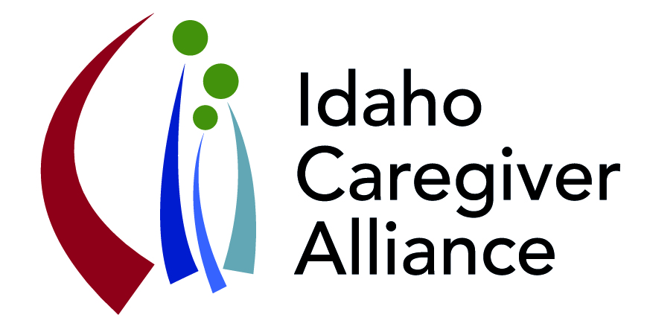**Idaho Caregiver Alliance**

**October 20, 2016; 1:00 – 4:00**

**Idaho Commission on Aging**

**341 West Washington Street, 2nd floor conference room**

***. . . advancing the well-being of caregivers by promoting collaboration***

***that improves access to quality support and resources across the lifespan.***

**Agenda**

1:00 p.m. **Introductions**

1:10 p.m. **Highlights and Insights from National Respite (ARCH) Conference**

Pam Oliason

What innovations and models of sustainability can be applied to Idaho?

1:35 p.m. **ICA Communications Plan – November is Family Caregiver Month in Idaho!**

Pam Oliason and Marilyn Sword

What’s on the ICA communication calendar and how can members be involved?

1:50 pm **Idaho Caregiver Action Plan**

Leadership Team

**Goal # 1: *Ensure a streamlined, coordinated system of supports for caregivers across the lifespan, recognizing the unique needs of Idaho’s diverse population.***

How can ICA move forward on this goal? What role can you or the organization you represent play in the achievement of this goal?

2:30 p.m. **Break**

2:40 p.m. **Idaho Caregiver Action Plan, Goal # 1**

Everyone: shared learning, opportunities, barriers, and next steps

3:10 **ICA Sustainability**

Pam Oliason and Sarah Toevs

What are the next steps for ICA – carry-forward dollars from Lifespan Respite grant and sustainability plan?

3:20 **Updates**

|  |  |
| --- | --- |
| Statewide Implementation of Powerful Tools for Caregivers (PTC) | **Caring for the Caregiver Conference**  Saturday, February 11, 2017 in Boise |
| Behavioral Health Planning Council | Idaho Healthcare Coalition (SHIP) |
| AARP Idaho Caregiver Resource Guide | Safety of Idahoans with Dementia Initiatives |
| Idaho Human Partnerships Conference | Other |

3:45 p.m. **Next Steps**

4:00 p.m. **Adjourn**

**Next Coalition Meeting: Thursday, February 23, 2017 (1-4 pm)**