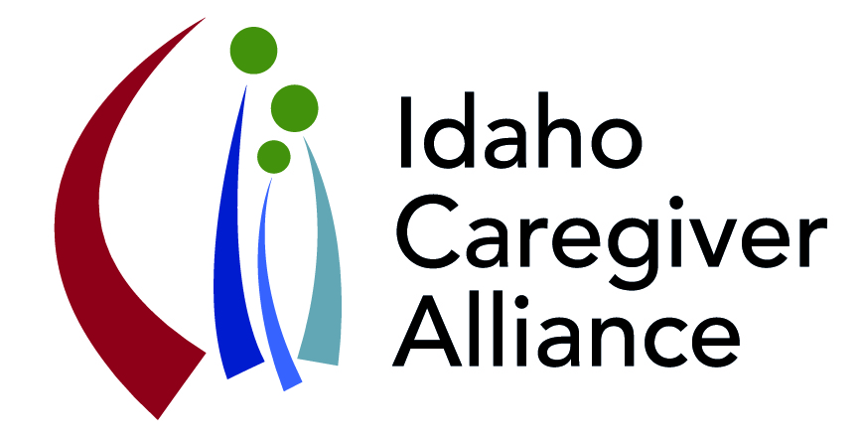**Idaho Caregiver Alliance**

**February 23, 2017; 1:00 – 4:00**

**Idaho Commission on Aging**

**341 West Washington Street, 2nd floor conference room**

***. . . advancing the well-being of caregivers by promoting collaboration***

***that improves access to quality support and resources across the lifespan.***

**Agenda**

1:00 p.m. **Introductions**

1:10 p.m. **Reports and Updates**

Caring for Caregiver Conference – how can this go statewide? – Sarah Toevs

Behavioral Health Planning Council – Jennifer Griffis

Idaho AARP Caregiver Guide – Cathy McDougal, Tristen Youngstrom

New Leadership at Idaho Commission on Aging (ICOA), Area Agency on Aging (AAA), and others

Judy Taylor – Director, ICOA Dan English, Area 1, AAA

Valerie Shell, Area 3, AAA Mike Hirschi (interim) Area 5, AAA

1:30 p.m. **SHIP Regional Collaboratives: Opportunities to embed the voice of the caregiver into the PCMH (person/family-centered medical home)**

Central Regional Collaborative - Gina Pannell

SW Regional Collaborative – Rachel Blanton

SE Healthcare Collaborative - Rhonda D’Amico

2:00 p.m. **2-1-1 Idaho Care (giver) Support**

Kelle Sweeney and Courtney Keith

2:10 p.m. **Powerful Tools for Caregivers (PTC)**

Highlights and next steps underway in Idaho

Kelle Sweeney and Regional Partners: Julie Christenson, Mike Hirschi, Morgan Nield

2:20 p.m. **Legislative Update**

Highlights and input - Tiffeny Stees

2:30 p.m. **Break**

2:40 p.m. **Idaho Caregiver Action Plan**

Caregiver Respite and Support Registry Taskforce – Pam Oliason

Sustainability – Sarah Toevs

3:10 **Opportunities on the Horizon**

Respite Registry – identification of providers: thinking outside of the box

Idaho Foster Parent Program –collaboration on training and other supports

New Federal Rules for Home Health Agencies

How can ICA support home health providers in supporting caregivers?

3:45 p.m. **Next Steps**

4:00 p.m. **Adjourn**

**Next Coalition Meeting: Thursday, June 29, 2017 (1-4 pm)**