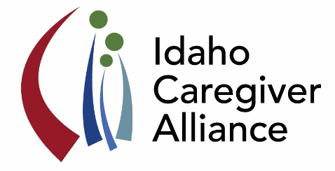**Idaho Caregiver Alliance**

**June 22, 2017; 1:00 – 4:00**

**Health Science Riverside Building, Rm 209 Boise State University**

To join from your computer, tablet or smartphone:

<https://global.gotomeeting.com/join/366042629>

By phone: [1 (312) 757-3121](tel:(312)%20757-3121); Access Code: 366-042-629

***. . . advancing the well-being of caregivers by promoting collaboration***

***that improves access to quality support and resources across the lifespan.***

**Agenda**

1:00 p.m. **Introductions and Updates**

1:20 p.m. **Report of Findings: 2017 Picking Up the Pace of Change: A State Scorecard on Long-Term Services and Supports (LTSS) for Older Adults, People with Physical Disabilities, and Family Caregivers**

Francoise Cleveland

1:35 p.m. **YES Program: Update on Youth Empowerment Services (YES)**

Trina Clark

1:50 p.m. **Idaho 2-1-1 Careline: A “How To” Overview: accessing information, posting information/services, etc.**

Courtney Keith

2:00 **Honoring Choices Idaho**

Stephanie Bender-Kitz

2:15 p.m. **Break**

2:30 p.m. **ARCH Lifespan Respite Grant: Discussion of new funding opportunity**

Pam Oliason

3:00 p.m. **Caregiver Integration Project: Central Health Regional Collaborative**

Marilyn Sword

3:15 p.m. **Celebrating Progress: Powerful Tools for Caregivers: Caregiver Education Pilot Program**

Tami Cirerol

3:30 p.m. **Celebrating Progress: Idaho Alzheimer’s Planning Group Behavioral Crisis and Access to Care**

Mike Berlin

3:45 p.m. **Next Steps**

4:00 p.m. **Adjourn**

**Next Coalition Meeting: Thursday, October 26, 2017 (1-4 pm)**