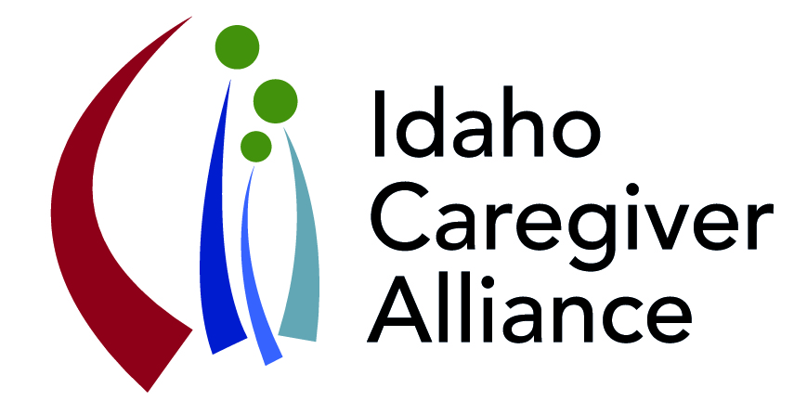**Idaho Caregiver Alliance**

**October 20, 2016; 1:00 – 4:00**

**Idaho Commission on Aging**

**341 West Washington Street, 2nd floor conference room**

***. . . advancing the well-being of caregivers by promoting collaboration***

***that improves access to quality support and resources across the lifespan.***

**Minutes**

**Attendees:**

|  |  |  |
| --- | --- | --- |
| Monique | Barber | Blue Cross of Idaho |
| Stephanie | Bender-Kitz | Honoring Choices Idaho, Jannus |
| Karen | Clark | Senior Health Insurance Benefit Advisors (SHIBA) |
| Judy | Cross | Interfaith Alliance of Idaho |
| Rhonda | D’Amico | Southeastern Idaho Public Health Department, SHIP Regional Collaborative |
| Stephen | Graci | Idaho Federation for Families for Children’s Mental Health |
| Stephanie | Hoffman | Policy Unit, Division of Behavioral Health, IDHW |
| Heather | Hoobs | Community Engagement Specialist, National MS Society |
| Steve | Kalina | Comfort Care |
| Jennifer | Keith | Area Agency on Aging of Eastern Idaho, E.I. Community Action Partnership |
| Maja | Ledgerwood | Syringa Hospital and Clinic |
| Renee | McCall | Interfaith Alliance of Idaho |
| Peggy | Munson | AARP-Idaho |
| Pam | Oliaison | Idaho Commission on Aging |
| Kim | Ouwehand | Treasure Valley Hospice |
| Melissa | Radloff | Legacy Corps, Jannus |
| Tammy | Ray | Idaho Home Choice, Division of Medicaid, IDHW |
| Diane | Ronayne | Boise at Home |
| Heidi | Smith | Idaho 2-1-1 Careline, IDHW |
| Tiffeny | Stees | ICA Intern, MSW Student |
| Kelle | Sweeney | ICA and Legacy Corps |
| Marilyn | Sword | ICA |
| Sarah | Toevs | Center for the Study of Aging, Boise State University |

**Highlights and Insights from National Respite (ARCH) Conference - Elevate Respite**

Pam Oliason, What innovations and models of sustainability can be applied to Idaho?

Please visit the conference [website](http://www.arch.memberlodge.org/2016-Program) for access to presentations, <http://www.arch.memberlodge.org/2016-Program>

A few of the highlighted presentations: examples of creative partnerships for sustainability and more

[Maximizing Respite Dollars Through Partnership and Collaboration: One Community’s Story of Caregiver Support](http://www.arch.memberlodge.org/resources/Documents/2016_Natl_Respite_Conf/PPTs/A-3%20J.%20Sparks%20Max%20Dollars%20Thru%20Partnerships.pdf)

[Montana's Lifespan Respite Cost Share Voucher Program](http://www.arch.memberlodge.org/resources/Documents/2016_Natl_Respite_Conf/PPTs/D-6%20V.%20Clear%20%20Cost-Share%20Voucher%20Montana.pdf)

[Climbing the Heights to Sustainability through Dynamic Partnerships](http://www.arch.memberlodge.org/resources/Documents/2016_Natl_Respite_Conf/PPTs/C-1%20E.%20Parker%20Climbing%20the%20Heights.pdf) (Rewarding Work Resource)

[Respite Agency Best Business Practices – Reaching New Altitudes in Respite Care](http://www.arch.memberlodge.org/resources/Documents/2016_Natl_Respite_Conf/PPTs/F-1%20J.%20Guevara%20Best%20Practices.pdf)

Pam has other resources available to share, Pam.Catt-Oliason@aging.idaho.gov

**ICA Communications Plan –** What’s on the ICA communication calendar and how can members be involved?

Pam Oliason and Marilyn Sword,

The Communications Plan is the centerpiece of Action Plan **Goal 2: Increase public awareness about unpaid family caregiving and help people within our communities identify as caregivers.**

**November is Family Caregiver Month in Idaho –** Governor Otter has signed a proclamation declaring this. We continue to try to get a ceremonial signing and will notify members if that is possible. We are working on a press release about the proclamation and the release of the plan. In the meantime, the proclamation can be used with local elected officials (mayors) to call attention to November as Family Caregiver Month.

Members of the ICA Leadership team have been meeting with local and state decision makers to present the Caregiver Action Plan. To date, we have met with Lisa Hettinger of DHW, Sam Haws of the Idaho Commission on Aging, and Senator Lee Heider. Sen. Heider has offered to take the Plan to the DHW Board – next meeting is Nov. 17. Presentations are planned to the Idaho Healthcare Coalition (SHIP), the Idaho Health Quality Planning Commission, and the House and Senate Health and Welfare Committees during the legislative session. Information about the Plan is regularly shared with the Behavioral Health Planning Council, the directors of the Area Agencies on Aging, and the Justice Alliance for Vulnerable Adults (JAVA). The Alliance also sponsored a track at the Human Partnerships Conference on October 5-6. This outreach work will continue and we welcome your support in helping us make connections and incorporating the family caregiver into your communications.

Currently, the Communications Plan is really just calendaring outreach efforts through the end of the legislative session (end of March). During that time we will be working on a more comprehensive plan. Stephanie Bender Kitz has sent a communications plan template and Rhonda D’Amico referred the group to the [Communications Plan](http://ship.idaho.gov/Portals/93/Documents/IHC/111815Attachment%202-Communications%20Plan%20Final.pdf?ver=2015-11-23-153603-657) developed for the Idaho SHIP, available at <http://ship.idaho.gov/Portals/93/Documents/IHC/111815Attachment%202-Communications%20Plan%20Final.pdf?ver=2015-11-23-153603-657>

**Call to Action:** let us know of events where Action Plan could be shared, send info to [stoevs@boisestate.edu](mailto:stoevs@boisestate.edu)

**Call to Action:** see attached for copy of Proclamation – share with leaders and other members of your community, Press release for November Family Caregiver Month in development

**Call to Action:** Media connection - looking for caregivers to participate; “Like” the Idaho Caregiver Alliance Facebook Page

**Call to Action:** members invited to participate on team; Diane Ronayne, Kim Ouwehand, and Rhonda D’Amico volunteered to offer their talents

**Idaho Caregiver Action Plan – Develop messaging to spread the word and increase visibility**

**Goal # 1: *Ensure a streamlined, coordinated system of supports for caregivers across the lifespan, recognizing the unique needs of Idaho’s diverse population.***

How can ICA move forward on this goal? What role can you or the organization you represent play in the achievement of this goal?

See attached for notes from small group think-tank

**ICA Sustainability**

Pam Oliason and Sarah Toevs, What are the next steps for ICA – carry-forward dollars from Lifespan Respite grant and sustainability plan?

Through the Idaho Commission on Aging’s Lifespan Respite grant project, the ICA has resources through August 2017. These resources will not enable the Alliance to continue at its full capacity, but implementation of the plan, quarterly meetings, and efforts to sustain the organization will continue.

Sustainability of management and operating functions of the ICA are emphasized by Action Plan **Goal 4: Ensure a coordinated voice for family caregivers in Idaho through the development of a sustainable structure for the Idaho Caregiver Alliance.** The ICA created a specific Sustainability Plan which outlines annual expenses associated with continuing to convene partners and develop new partners to implement and evaluate the Idaho Family Caregiver Action Plan. The goals and objectives of the plan, if implemented will vastly improve the support environment for caregivers so they can continue in their role.

**Updates**

* **Statewide Implementation of Powerful Tools for Caregivers (PT**C) – PTC classes are currently underway in several regions across the state. PTC class leaders from Grangeville and Idaho Falls have expressed interest in becoming Master Trainers, thereby allowing them to train additional class leaders in their areas. Staff from Child Protective Services from Lapwai have indicated that they would like to train staff to lead classes on the Reservation. Contact Kelle Sweeney, [ksweeney@jannus.org](mailto:ksweeney@jannus.org), for more information.
* **Idaho Human Partnerships Conference** – over 800 attendees, caregiver track a great success; see attached handout for a list of topics.
* **AARP Idaho Lifespan Caregiver Resource Guide** – resource guide underdevelopment
* Idaho Healthcare Coalition (SHIP) – visit website, <http://ship.idaho.gov/AboutUs/tabid/3040/Default.aspx>
* **Safety of Idahoans with Dementia Initiatives** – the Idaho Alzheimer’s Planning Group in partnership with the Idaho Health Care Association and Idaho Alzheimer’s Association is continuing to work on this issue, please contact Mike Berlin for additional information, [MikeBerlin@boisestate.edu](mailto:MikeBerlin@boisestate.edu)
* **Caring for the Caregiver Conference**,Saturday, February 11, 2017 in Boise, for more information contact Mary Holden, [maryholden@boisestate.edu](mailto:maryholden@boisestate.edu)

**Next Coalition Meeting: Thursday, February 23, 2017 (1-4 pm)**